**21. Write a program to demonstrate pre and post-processors in JMeter**.

**Pre-processor:**

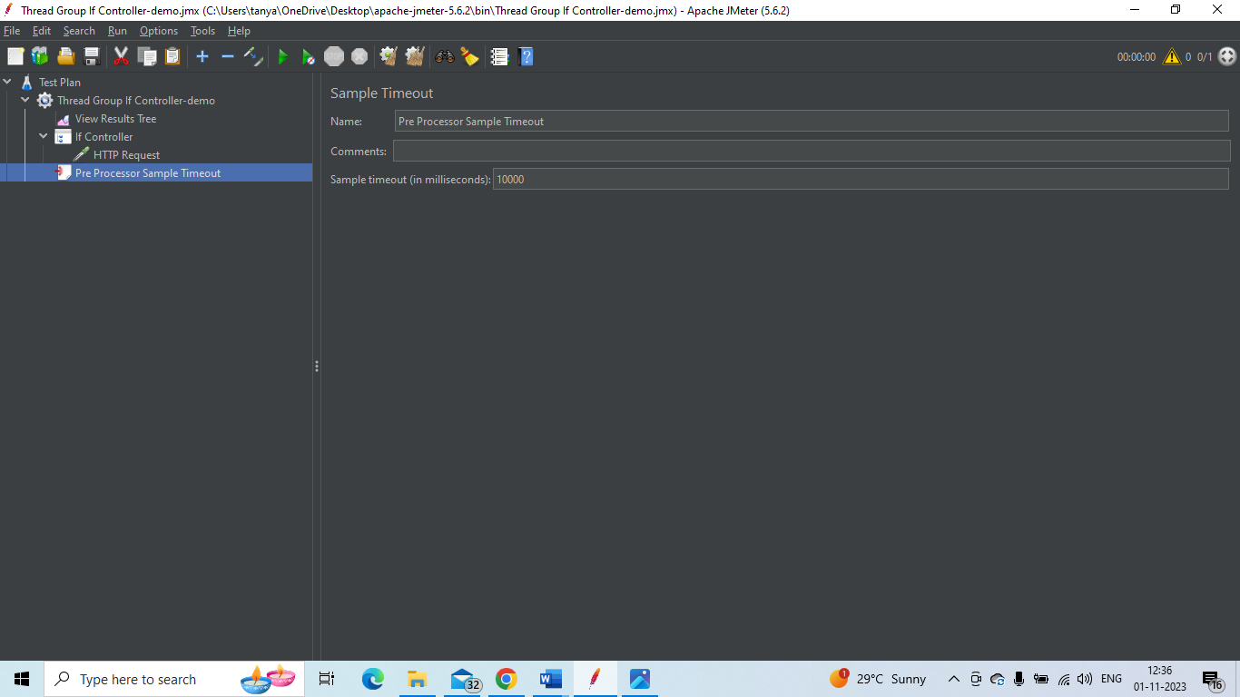

**Post-Processor:**

